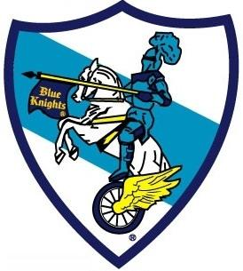
Blue Knights International
Law Enforcement Motorcycle Club
Maryland I Crab Feast Registration
Date: |  | August 8, 2026 | Time: | 2:00pm – 6:00pm (Doors open at 1:45pm)
Location: |  | Martins Crosswinds 7400 Hanover Parkway Greenbelt, Maryland
Host Hotel: |  | Holiday Inn Express 7200 Hanover Parkway Greenbelt, Maryland
Phone |  | 1-301-982-7200 (Hotel)

PLEASE PRINT CLEARLY:
Name #1: |  |  |  |  |  |  |  |  |  |  |  |  |  |  |  |  | Name #2:
Street: |  |  |  |  |  |  |  |  |  |  |  |  |  |  |  |  | Street
City: |  |  |  |  |  |  | State: |  |  |  |  | Zip: |  |  |  |  | City: |  |  |  |  |  |  | State: |  |  | Zip:
Phone: |  |  |  |  |  |  |  |  |  |  |  |  |  |  |  |  | Phone:
Email: |  |  |  |  |  |  |  |  |  |  |  |  |  |  |  |  | Email:
Chapter #: |  |  |  |  |  |  |  |  | Millage:

Registration:
Adult |  | # |  |  | X | $100.00 | =
Child (12 yrs old or younger) |  | # |  |  | X | $55.00 | =
 |  |  |  |  | Total Due:
Make check or money order payable to Blue Knights Maryland I
Mail check and registration form to: |  | John Bull  C/O Blue Knights  7830 Catherine Ave  Pasadena, Maryland 21122
Maryland I Contacts: | Byron Hope 202-904-4892 / mpdcleo124@aol.com
 | Natalie “Nat-Nat” Gaston 301-318-5010

Special Note:

All Registrations must be made by July 31, 2026, in order to ensure it is received in time. Due to logistical reasons, there will be no onsite walk-in registrations.

